Visualization
Above the crown of your head, the pure qualities of the body, speech and mind of all Buddhas manifests as White Tara. Her body is in the nature of radiant white light. Her right hand extends over her right knee, palm outward, in the gesture of granting realizations; her left hand at her heart holds the stem of a lotus flower blossoming over her left shoulder. Youthful and beautiful, she is seated in the lotus posture. She has all the signs and marks of a Buddha and has seven eyes (face, palms, soles, third eye). She looks at you and all sentient beings with complete acceptance and compassion.
At Tara’s heart is a horizontal white moon disk. At its center is the white syllable TAM, the essence of her enlightened realizations.
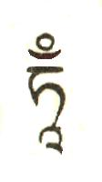
Light rays shine forth from the TAM and, extending infinitely throughout space, bring back with them whatever kind of life force in you has been scattered or lost.

This dissolves into the TAM in the form of light. Again light rays radiate from the TAM and, extending infinitely, bring back with them from throughout space the power and inspiration of all the Buddhas and bodhisattvas. This also dissolves into the TAM at her heart. Further, the essence of the strengthening power inherent in all the four elements of earth, water, fire and air, as well as the space element, throughout the universe, absorb into the TAM in the form of five-colored nectar-light (white, yellow, red, green, blue).
From the TAM at her heart, light and nectar now flow into your body, downward through the crown of your head. They fill your entire body, dispelling all negative karma, disturbing attitudes, negative emotions, disease, interferences, and dangers of untimely death. All these leave your body in the form of dirty liquid, soot and smoke, exiting your body downward to enter deep into the earth. Your body becomes pure and radiantly clear. Your mind too becomes clear and blissful. Allow yourself to feel, simply yet strongly, the purity of your mind and body in this state.

Mantra recitation

While doing this visualization, recite as much as possible:

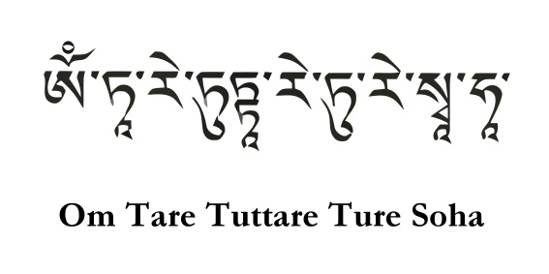

During and after the recitation, you should think and feel:

“I am freed of all negative forces of body, speech and mind.
My entire being is liberated and pure. I will use my life in a meaningful way to transform my mind; develop love, compassion, and the six transcending attitudes; and act in ways that
benefit others, myself, and our environment.”
While chanting, imagine rays of pure white light emanating from every pore of your body, extending in all directions throughout space. These rays of light touch all beings everywhere, and penetrate their entire being such that they are also freed of all negativities of body, speech and mind. Feel from your heart that you and all beings are now freed, with bodies and minds entirely peaceful and pure. Rest calmly in this eased state.

Dedication

Conclude by thinking: May all my thoughts, words and actions derive from a sense of solidarity with all beings. May the power of this practice increase my commitment to transforming body, speech and mind to be a greater source of peace, love and joy for myself and for others. May my practice continue to open my heart gently into natural and warm compassion. May the blessings of meditating with Tara strengthen my body and mind to be able to make more joyous effort always.

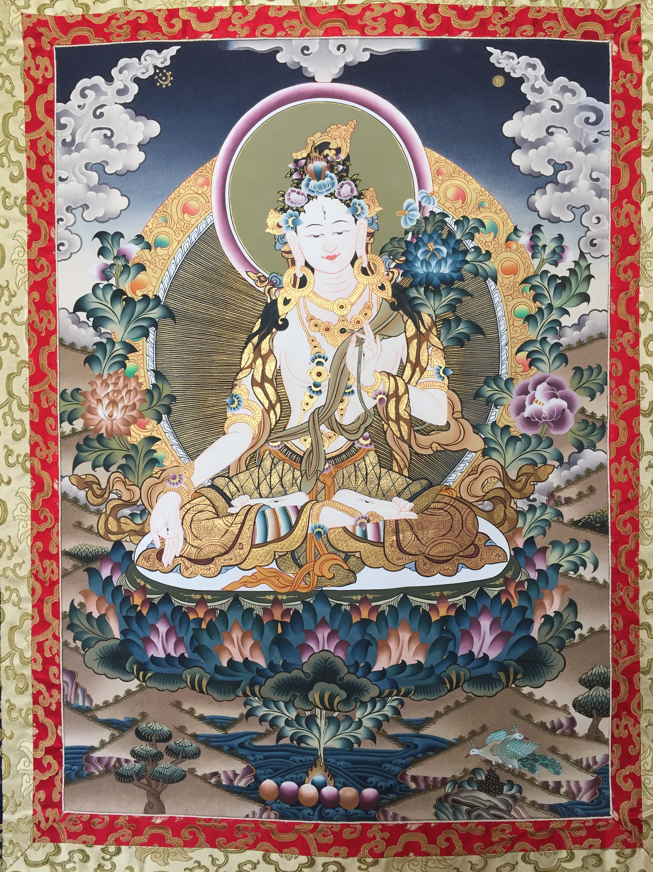

Based on Tibetan traditions, this meditation uses the image and ideals associated with White Tara to assist in our practice of calming and purifying our loving awareness of both self and others.

Meditation with White Tara

With an intention to transform our body, speech and mind
to be of great benefit to all beings by engaging every day in the six perfect practices of generosity, ethics, patience, concentration, effort and wisdom, we remember
the four immeasurable wishes:

May all sentient beings have happiness and its causes
May all sentient beings be free of suffering and its causes
May all sentient beings experience abundant fulfillment
May all sentient beings abide in equanimity, free of bias



bodhimindcenter.org

